CL307-SPRING-2021-02 MANUAL

**QUESTION # 1:**

1. A
2. B
3. C
4. B
5. C
6. A
7. C
8. D
9. B
10. A
11. E
12. C
13. A
14. C
15. C
16. A
17. A
18. B
19. C

**QUESTION # 2:**

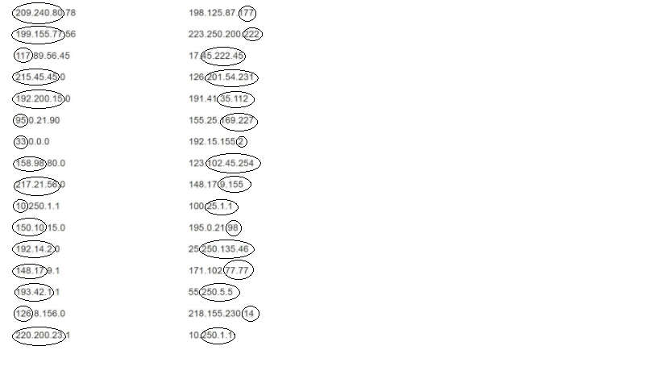

**QUESTION # 3:**

1. 192.149.24.0
2. 150.203.0.0
3. 10.0.0.0
4. 186.13.23.0
5. 223.69.0.0
6. 200.120.135.0

**QUESTION # 4:**

1. 0.0.0.11
2. 0.0.230.19
3. 0.10.10.10
4. 0.0.0.11
5. 0.0.23.20
6. 0.0.0.215

**QUESTION # 5:**

1. 255.255.0.0
2. 255.255.255.0
3. 255.0.0.0
4. 255.0.0.0
5. 255.255.255.0
6. 255.255.255.0
7. 255.0.0.0
8. 255.255.0.0

CL307-SPRING-2021-03 MANUAL

**QUESTION # 1:** 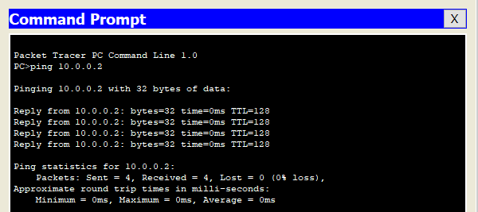

**QUESTION # 2:**

1. Cross-over cable is used when there are similar devices.
2. Straight cable is used when there are different devices.

**QUESTION # 4:**

1.Straight, as it is PC to switch connection

2. Straight, as it is switch to router connection

3. Cross-over, as it is router to router connection